WASTE MANAGEMENT SYSTEM&RECYCLING TRAKER
A MINI-PROJECT REPORT
Submitted by

SWETHA R 240701550

in partial fulfillment of the award of the degree
of
BACHELOR OF ENGINEERING
IN
COMPUTER SCIENCE AND ENGINEERING

RAJALAKSHMI ENGINEERING COLLEGE, CHENNAI
An Autonomous Institute
CHENNAI
NOVEMBER 2025

BONAFIDE CERTIFICATE
Certified that this project “WASTE MANAGEMENT SYSTEM & RECYCLING TRAKER” is the bonafide work of “SWETHA R” who carried out the project work under my supervision.

SIGNATURE
MRS.DEEPA
ASSISTANT PROFESSOR SG
Dept. of Computer Science and Engg,
Rajalakshmi Engineering College
Chennai

This mini project report is submitted for the viva voce examination to be held on __________

INTERNAL EXAMINER EXTERNAL EXAMINER
ABSTRACT

The Waste Management and Recycling Tracker is a database-driven application designed to digitalize and optimize the waste collection, segregation, and recycling process within urban and residential areas. The system aims to promote efficient waste disposal habits among households and streamline communication between waste collectors, recycling centers, and administrative authorities.

This project enables households to register their waste types (such as recyclable, and non-recyclable) and tracks the quantity of waste collected through an interactive dashboard. Waste collectors can log collection details through a simple form interface, while the system automatically records data into a centralized Oracle database. Reward points are assigned to households based on the amount and type of recyclable waste they generate, encouraging community participation in sustainable waste management practices.

Additionally, the system allows administrators to monitor recycling performance, track daily or monthly collection statistics, and analyze data trends through visual dashboards. The integration of Java (Swing/JSP and Servlet) for the frontend, Oracle 11g as the backend database, and JDBC for connectivity ensures real-time data access, accuracy, and scalability.

Overall, this project provides an innovative and environmentally conscious approach to waste tracking, reducing manual errors, improving transparency in waste collection operations, and promoting recycling as a sustainable community effort.

ACKNOWLEDGEMENT

We express our sincere thanks to our beloved and honorable chairman MR. S. MEGANATHAN and the chairperson DR. M.THANGAM MEGANATHAN for their timely support and encouragement.
We are greatly indebted to our respected and honorable principal
Dr. S.N. MURUGESAN for his able support and guidance.
No words of gratitude will suffice for the unquestioning support extended to us by our Head Of The Department Dr. E.M. MALATHY and our Deputy Head Of The Department Dr. J. MANORANJINI for being ever supporting force during our project work
We also extend our sincere and hearty thanks to our internal guide Dr. R , BHUVANESHWARI for her valuable guidance and motivation during the completion of this project.
Our sincere thanks to our family members, friends and other staff members of computer science engineering.
1. APARNA R
2. ASHMITHA A

TABLE OF CONTENTS

CHAPTER NO. TITLE PAGE NO
ABSTRACT iv

1 INTRODUCTION 1
1.1 INTRODUCTION 8
1.2 SCOPE OF THE WORK 8
1.3 PROBLEM STATEMENT 8
1.4 AIM AND OBJECTIVES OF THE PROJECT 8
2 SYSTEM SPECIFICATIONS
2.1 SOFTWARE SPECIFICATIONS 9
3 MODULE DESCRIPTION 10
4 CODING 11
5 SCREENSHOTS 16
6 CONCLUSION AND FUTURE ENHANCEMENT 18
REFERENCES 19

LIST of figures
FIGURE NO. | TITLE | PAGE NO.
5.1 | INTRODUCTION PAGE | 17
5.2 | HOUSEHOLD DETAILS | 17
5.3 | COLLECTOR DETAILS | 18
5.4 | WASTE COLLECTION FORM | 18
5.5 | HOUSEHOLD STATUS | 19
5.6 | TOP WASTE COLLECTORS | 19
5.7 | TOP ECO-FRIENDLY HOUSES | 19
5.8 | WASTE COLLECTION ANALYSIS | 20
5.9 | DATABASE CREATION | 20

CHAPTER 1
INTRODUCTION
  - INTRODUCTION
The Waste Management and Recycling Tracker digitalizes waste collection and recycling processes. It provides a simple platform for households and collectors to record data efficiently. The system ensures transparency, accuracy, and promotes eco-friendly waste disposal.
  - SCOPE OF THE WORK
The project manages household registration, waste collection, and recycling tracking. It enables collectors to log details easily and provides dashboards for performance analysis. The system can be extended for municipal or community-level waste management.
  - PROBLEM STATEMENT
Manual waste tracking is inefficient, error-prone, and lacks accountability. Households are not rewarded for proper recycling habits. An automated system is required to record, monitor, and analyse waste collection effectively.
  - AIM AND OBJECTIVES OF THE PROJECT
The aim and objective of this project are to design a database-driven system for efficient waste collection and recycling management.
It focuses on automating data entry, improving accuracy, and promoting eco-friendly practice. The system maintains a centralized record of waste details, reward points, and recycling performance.

CHAPTER 2
SYSTEM SPECIFICATIONS
2.1 SOFTWARE SPECIFICATIONS
Operating System | : | WINDOWS 11
Front – End | : | JSP
Back - End | : | Oracle Database
Language | : | Java,SQL

CHAPTER 3
MODULE DESCRIPTION
This application consists of three modules. The description of the modules are as follows:
1. Household Module
This module manages household registration and stores details like name, address and contact information. It allows users to view their waste submission history and earned reward points. Households can track the type and quantity of waste submitted for collection. It serves as the primary data source for waste monitoring and reward calculation.
2. Collector Module
This module enables collectors to record daily waste collection details from registered households . Collectors can update the type and quantity of waste collected for each visit. It ensures data accuracy and avoids duplication during waste entry. The module helps monitor collector performance and route efficiency.
3. Reward and Analysis Module
This module calculates reward points based on recyclable waste contributions.
It generates dashboards showing top-performing households and collection trends. Admins can analyse data to improve recycling awareness and efficiency. It promotes active participation in sustainable waste management.

CHAPTER 4
SAMPLE CODING
package com.wastemgmt;
import java.io.*;
import jakarta.servlet.ServletException;
import jakarta.servlet.annotation.WebServlet;
import jakarta.servlet.http.*;
import java.sql.*;
@WebServlet("/AddCollectorServlet")
public class AddCollectorServlet extends HttpServlet {
private static final long serialVersionUID = 1L;
protected void doPost(HttpServletRequest request, HttpServletResponse response)
throws ServletException, IOException {
String name = request.getParameter("name");
String zone = request.getParameter("zone");
Connection conn = null;
PreparedStatement ps = null;

try {
// Load Oracle JDBC driver
Class.forName("oracle.jdbc.driver.OracleDriver");
// Connect to the database
conn = DriverManager.getConnection(
"jdbc:oracle:thin:@localhost:1521:xe",
"waste_management",
"apar@1234"
);
// Insert into collector table
String sql = "INSERT INTO collector (collector_id, name, zone) VALUES (collector_seq.NEXTVAL, ?, ?)";
ps = conn.prepareStatement(sql);
ps.setString(1, name);
ps.setString(2, zone);

int rows = ps.executeUpdate();
// ✅ Redirect back to JSP with message
if (rows > 0) { response.sendRedirect("addcollector.jsp?message=Collector+added+successfully!");
} else { response.sendRedirect("addcollector.jsp?message=Error+adding+collector!");
}} catch (Exception e) {
e.printStackTrace();
// ✅ Redirect with exception message (URL-encoded)
response.sendRedirect("addcollector.jsp?message=Exception:+"
+ e.getMessage().replace(" ", "+"));
} finally {
try {
if (ps != null) ps.close();
if (conn != null) conn.close();
} catch (Exception ignored) {}
}
}
} Sample 1
This module acts as a bridge between the collector interface and the database.
It processes form data submitted by collectors and stores it in the waste collection table.The servlet handles input validation, database connectivity, and response generation.It ensures smooth data transfer and real-time updates in the waste management system.
package com.wastemgmt;
import java.io.*;
import jakarta.servlet.ServletException;
import jakarta.servlet.annotation.WebServlet;
import jakarta.servlet.http.*;
import java.sql.*;
@WebServlet("/AddHouseholdServlet")
public class AddHouseholdServlet extends HttpServlet {
private static final long serialVersionUID = 1L;
protected void doPost(HttpServletRequest request, HttpServletResponse response)
throws ServletException, IOException {

// Retrieve form data
String name = request.getParameter("name");
String address = request.getParameter("address");
String contact = request.getParameter("contact_no");
Connection conn = null;
PreparedStatement ps = null;
try {
// Load Oracle JDBC driver
Class.forName("oracle.jdbc.driver.OracleDriver");
// Connect to database
conn = DriverManager.getConnection(
"jdbc:oracle:thin:@localhost:1521:xe",
"waste_management",
"apar@1234"
);
// Prepare SQL statement
String sql = "INSERT INTO household (household_id, name, address, contact_no) " +"VALUES (household_seq.NEXTVAL, ?, ?, ?)";
ps = conn.prepareStatement(sql);
ps.setString(1, name);
ps.setString(2, address);
ps.setString(3, contact);
// Execute update
int rows = ps.executeUpdate();
// Redirect with message parameter
if (rows > 0) {
response.sendRedirect("addhousehold1.jsp?message=Household+added+successfully!");
} else {
response.sendRedirect("addhousehold1.jsp?message=Error+adding+household!");
}

} catch (Exception e) {
e.printStackTrace();
// Redirect with the exception message (encoded for URL)
response.sendRedirect("addhousehold1.jsp?message=Exception:+"
+ e.getMessage().replace(" ", "+"));
} finally {
try {
if (ps != null) ps.close();
if (conn != null) conn.close();
} catch (Exception ignored) {}
}
}
} Sample 2
This servlet handles the registration of new households into the system.It collects form data, validates inputs, and inserts details into the database.After successful registration, it generates a confirmation or success message.The module ensures accurate and secure data entry for new household records.

CHAPTER 5
SCREEN SHOTS
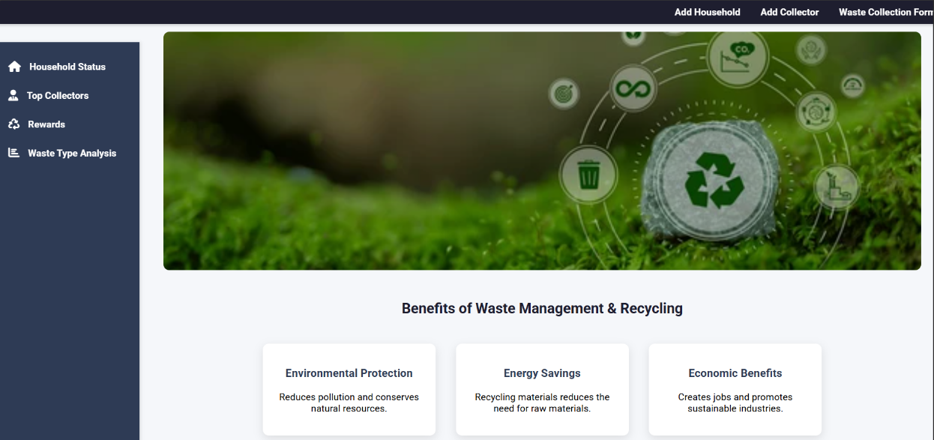
Fig 5.1 Introduction page
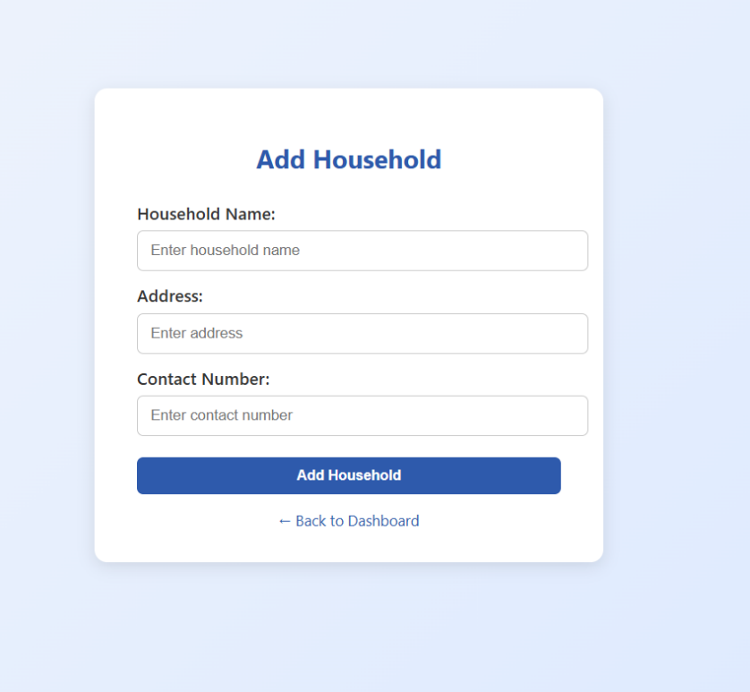
Fig 5.2 household details
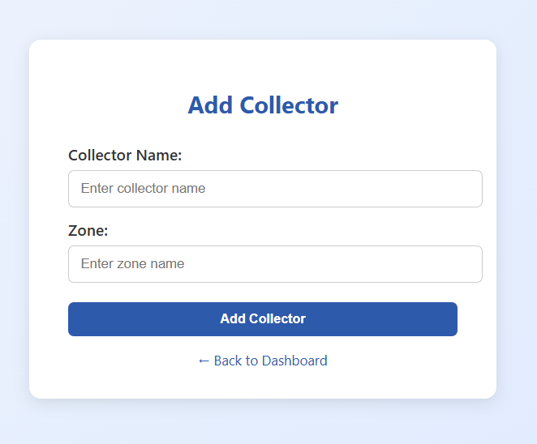
Fig 5.3 collector details

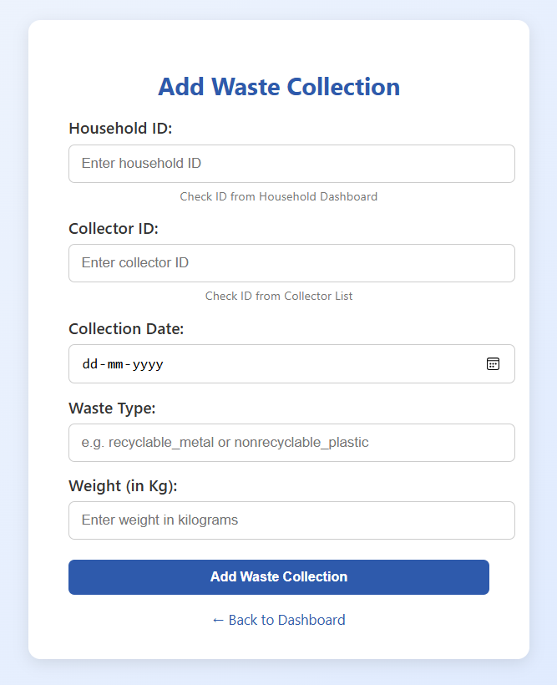
Fig 5.4 Waste Collection form
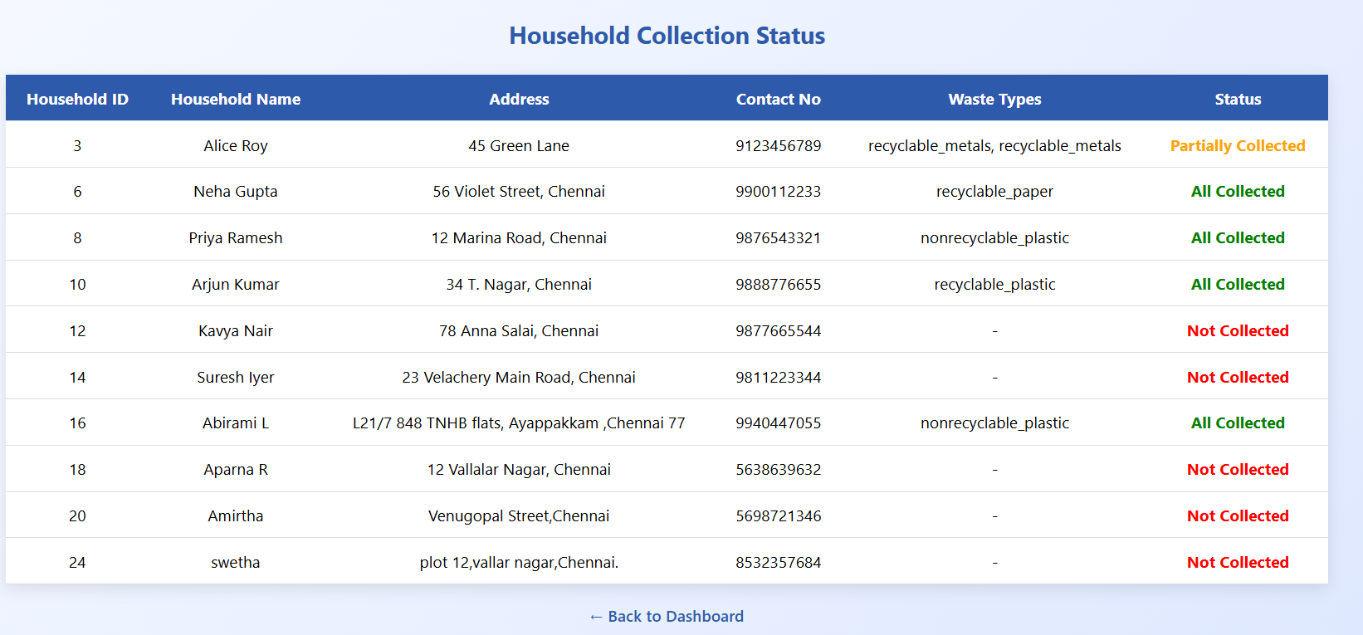
Fig 5.5 Household Status
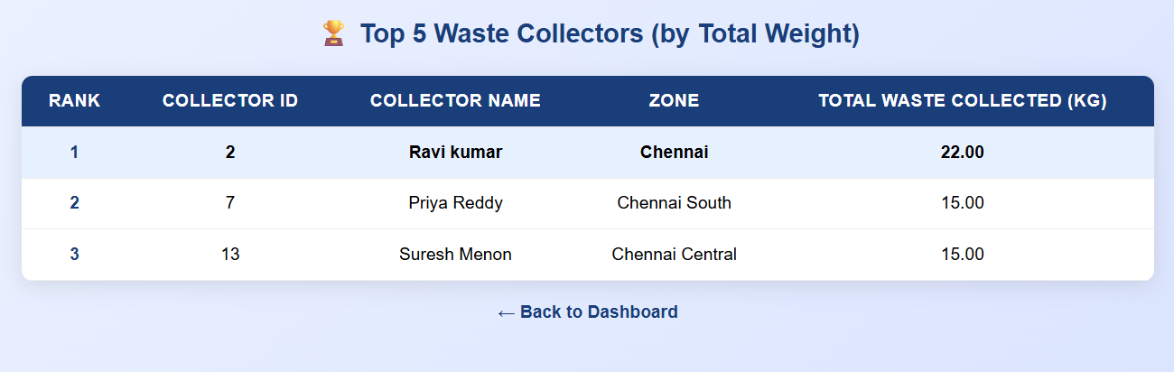
Fig 5.6 Top Waste Collectors
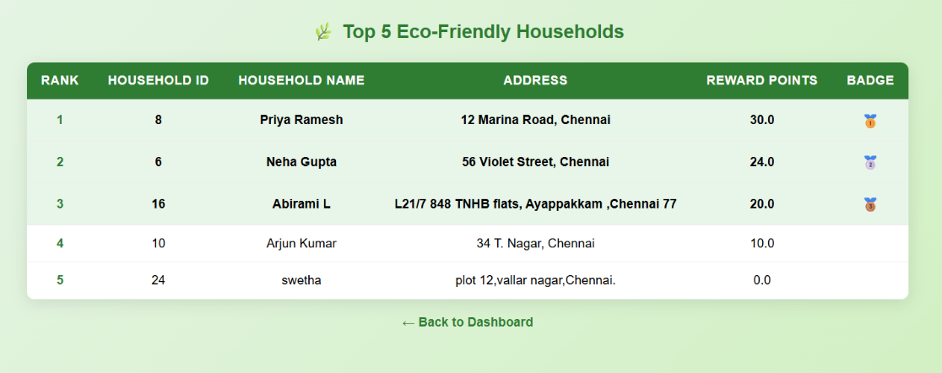
Fig 5.7 Top Eco-friendly Households
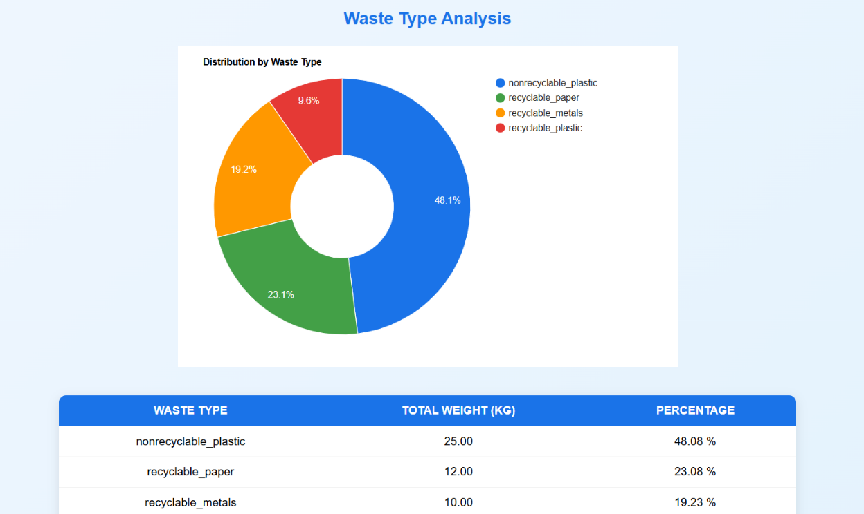
Fig 5.8 Waste Collection Analysis
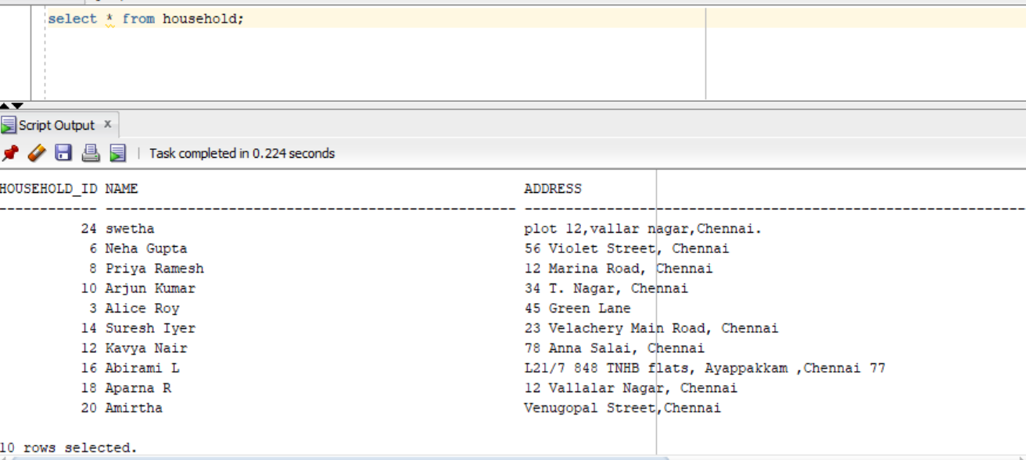
Fig 5.9 Database creation

CHAPTER 6
CONCLUSION AND FUTURE ENHANCEMENT
The Waste Management and Recycling Tracker successfully automates the process of recording and monitoring waste collection and recycling activities.
It ensures transparency between households, collectors, and recycling centers through a centralized database. The system encourages eco-friendly practices by rewarding users for proper waste segregation and recycling .It also helps authorities analyze waste data and improve collection efficiency .In the future, this project can be enhanced by adding real-time GPS tracking for waste vehicles. Mobile app integration can make data entry and updates more convenient for users and collectors.
AI-based prediction models can be included to forecast waste generation trends.
These enhancements will make the system smarter, scalable, and more impactful for sustainable waste management.

REFERENCES
- W3Schools – SQL Tutorial
- Javatpoint – JDBC Tutorial
- GeeksforGeeks – Servlets in Java
- TutorialsPoint – JSP Tutorial
- Oracle – JDK 17 Documentation
- Javatpoint – Oracle Database Tutorial
- W3Schools – HTML Tutorial
- GeeksforGeeks – Java Swing Overview
- Wikipedia – Main Page
- TutorialsPoint – Software Project Management

